11. Add dependency Eureka client in ProductService pom.xml

<dependency>

<groupId>org.springframework.cloud</groupId>

<artifactId>spring-cloud-starter-netflix-eureka-client</artifactId>

</dependency>

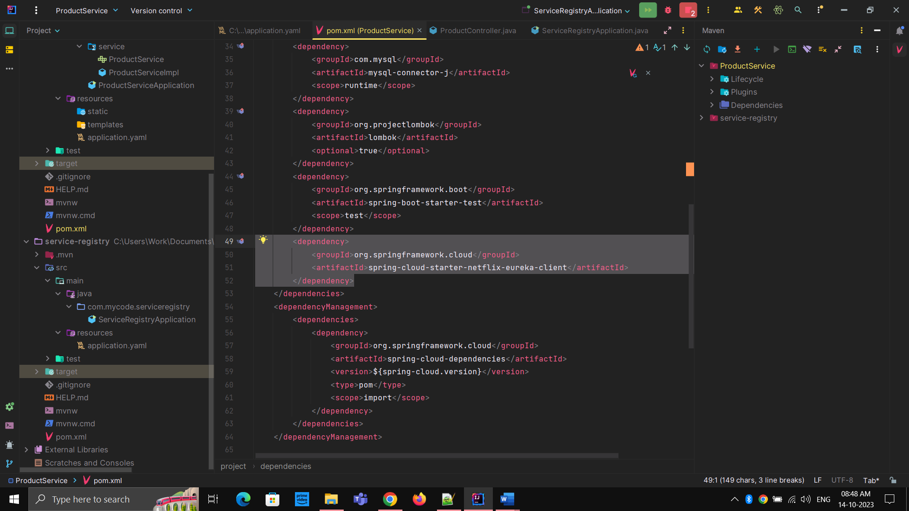

12. We need to specify to which eureka server this client needs to connect. For that we will add configuration in application.yaml

I used curly braces that means   
Whenever the environment variable is available it will use “EUREKA_SERVER_ADDRESS” and whenever environment variable is not available it will use the other part of that link.

13. Add eureka configuration in application.yaml

eureka:  
 instance:  
 prefer-ip-address: true  
 client:  
 fetch-registry: true  
 register-with-eureka: true  
 service-url:  
 defaultZone: ${EUREKA_SERVER_ADDRESS:http://localhost:8761/eureka}

